Write a Prolog Program to suggest Dieting System based on Disease.

**AIM**

To write a Prolog program that suggests an appropriate diet based on a person’s disease.

**ALGORITHM**

1. Start the program.
2. Define facts in the form diet(Disease, SuggestedDiet) for each disease.
3. Write a rule suggest_diet(Disease) to display the suggested diet for the input disease.
4. Load the program into the Prolog interpreter.
5. Query the program using suggest_diet(Disease). to get the diet recommendation.
6. Prolog retrieves and displays the diet for the specified disease.
7. Stop.

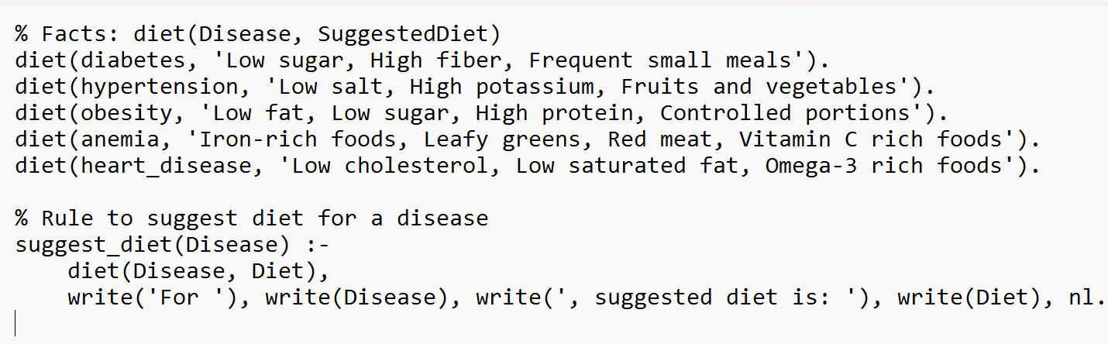

**OUTPUT:**

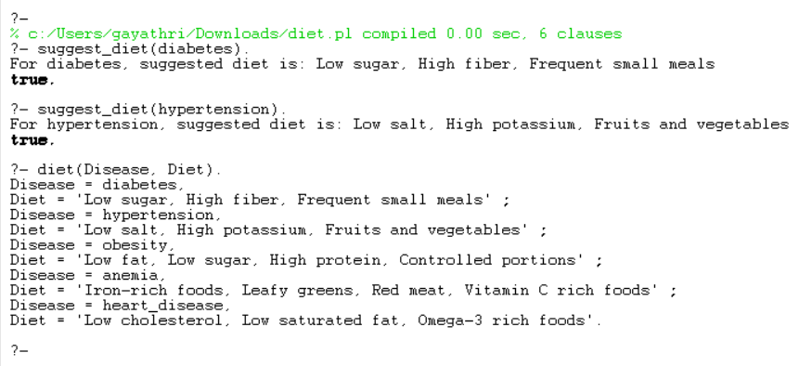

**RESULT**

The program successfully suggests the appropriate diet for a given disease, providing dietary recommendations to the user.